

BEAUSEJOUR SKATING CLUB
ANNUAL GENERAL MEETING
Sunday, February 23, 2025
Beausejour Sportsplex

Meeting Agenda
- Call to Order
- Pass Minutes from 2024 AGM
- Committee Reports
- Election of Executive
- Skate Manitoba By-law adoption
- Adjournment



Beausejour Skating Club
Minutes of Meeting for AGM

March 17, 2024
Sun Gro Centre, Beausejour, MB
Chair: Pam Schirle
Secretary: Andrea Swain
Members Present: 14 (see paper copy for list of names)
Call to order 10:25 am
Meeting Minutes/Committee Reports:
-Minutes from last AGM circulated with AGM package and reviewed.
-Motion to pass 2023 AGM minutes from March 24, 2023 as presented by Andrea Swain; 2nd by Santana
Boulet; carried.
3. Pam Schirle presented the committee reports.(see attached)
4. Pam Schirle presented inancial report that was prepared by Dave Roy.
Motion to accept reports as presented Crystal Shoup; 2nd by Angela Schoenberger; carried,
5. Nominations for the 2024/2025 Board of Directors:
-Call for nominations for the position of President. Pam Schirle nominated. No other nominations.
-Call for nominations for the position of Vice-President. No nominations. Position remains vacant.
-Call for nominations for the position of Treasurer. Dave Roy nominated. No other nominations.
-Call for nominations for the position of Secretary. Morgan Roy nominated. No other nominations.
-Call for nominations for the position of Director, Test & Competition. No nominations. Position remains
vacant.
-Call for nominations for the position of Director, Registration. Andrea Swain nominated. No other
nominations.
-Call for nominations for Director, Fundraising. Michele Lachance nominated. No other nominations.
-Call for nominations for Director, CanSkate. No nominations. Position remains vacant.
-Call for nominations for Director of Marketing. Santana Boulet nominated. No other nominations.
-Lac Du Bonnet CanSkate. No nominations received.
-Call for nominations for Director of Ice Show Chair. Aimee Epp nominated. No other nominations.
-Robyn Emberly was nominated as Members at Large.
All nominated were elected as presented. Motion by Andrea Swain; 2nd by Morgan Roy; carried.
6. Meeting adjourned at 10:54 am.
2024-2025 President’s Report
Submitted by Pam Schirle

The Beausejour Skating Club has continued to grow this season. We also had a waitlist for our Sunday Canskate program! Our group program has continued to grow as well, and we offered some free “come try” synchro days to hopefully generate some interest in developing a synchro team in the coming years.

From a Board standpoint – we are grateful but sad to see our Registrar Andrea Swain leave. Her volunteerism has been invaluable and was instrumental in helping to get our online registration system UPLIFTER up and running. Thank you Andrea!

A special thank you to all of our skaters, families, Coaches, Program Assistants, and hardworking Board members for another successful season!

2024-2025 Registration Report
Submitted by: Andrea Swain

In 2024-25, the Beausejour Skating Club has continued to expand our use of the Uplifter Service to deliver and host our website and online registration system. The support of the Uplifter technical help team was invaluable in helping us transfer the previous year to the 2024-25 season making for a very easy registration set-up. We opened registration on August 1st this year and we had a fairly good response from returning and new skating families. In 2024-2025 we continued to have interest in registering for our CanSkate program well into January. We had a number of new families join throughout the season. As of February 2025, we have the following numbers of skaters:

Friday:
CanSkate group had 29 registered skaters.
Private Session had 9 skaters.
Group Session had 13 skaters.

Sunday:
CanSkate group had 35 registered skaters.
Private Session had 5 skaters.
Group Session had 10 skaters.

As a note, we were able to increase the maximum number of skaters in CanSkate due to our high level of Program Assistants and hiring a Junior Coach.

We also used the Uplifter program to register our Board members with Skate Canada. This is required for insurance purposes. We will continue this process in future years.

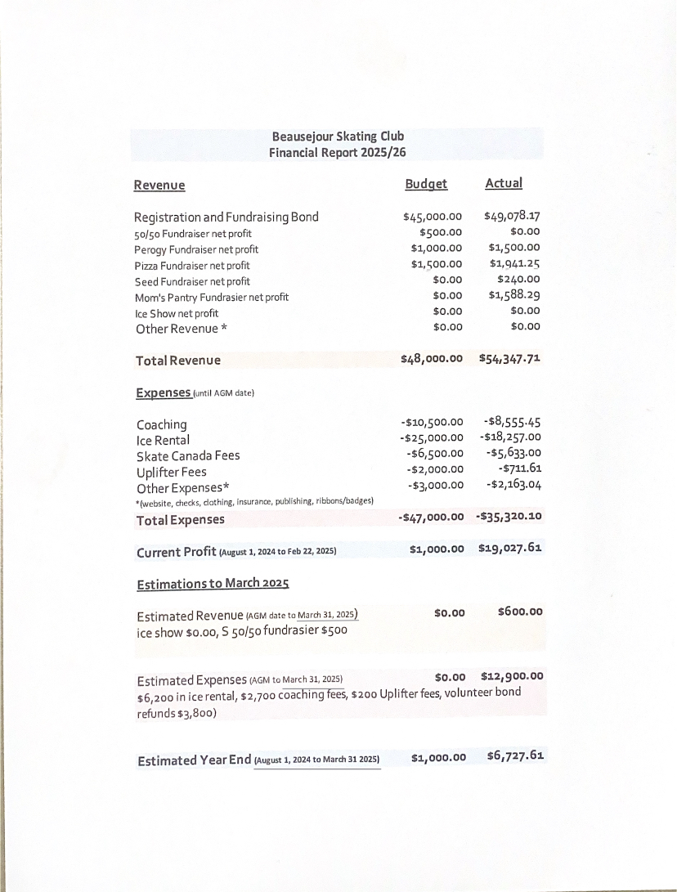

BEAUSEJOUR SKATING CLUB EXECUTIVE POSITIONS

The following people held the Executive positions for the 2024-2025 season:

Past President: Terry Buss
President: Pam Schirle
Vice President: Vacant
Treasurer: David Roy
Secretary: Morgan Roy
Directors:

Registration: Andrea Swain
Fundraising: Michele LaChance
Canskate: VACANT
Marketing: Santana Boulet
Ice Show Chairperson: Aimee Epp

Professional Coaches
Rep: Sarah Murkin-Debeuckelaere
Members at Large:

PROPOSED CANDIDATES FOR THE 2025-2026 EXECUTIVE

The following individuals have submitted their names for consideration:

President: Pam Schirle
Vice President: Vacant
Treasurer: David Roy
Secretary: Morgan Roy

Registration: Terra Smyk
Fundraising: Michele LaChance
Canskate Coordinator: Vacant
Marketing: Santana Boulet
Ice Show Chair: Aimee Epp
Member at Large:

Professional Coaches
Rep: Sarah Murkin-Debeuckeleare

Would anyone else like to be considered for any of the above listed positions?

